

SNADAI

Contemporary Art Gallery, Auction and Artist Submission Platform

PROJECT DESCRIPTION SUMMARY
Snadai is a web platform that helps art collectors explore artworks, save favourites, join a live auction and purchase art online. It also gives artists a clear place to submit their work for review. The project uses a simple gallery style and secure user accounts to make the experience easier for both art buyers and artists.

A comprehensive project submitted in partial satisfaction of the requirements for the degree of
Bachelor of Science (Hons) in Software Engineering

By: Hor Kimly

Faculty of Information and Communication Technology - Academic Year: 2026

SNADAI

The comprehensive project of Hor Kimly is approved.

Approval Role | Name and Signature
Main Advisor | [Insert Advisor Name and Signature]
Second Reviewer / Advisor | [Insert Name and Signature]
Program Leader | [Insert Program Leader Name and Signature]

- Copyright Reserved -

PROJECT METADATA
Metadata Item | Project Information
Project Title | Snadai - Contemporary Art Gallery, Auction and Artist Submission Platform
Project Credit | 6
Candidate | Hor Kimly
Project Advisor | [Insert official advisor name]
Program | Bachelor of Science (Hons) in Software Engineering
Field of Study | Software Engineering
Faculty | Faculty of Information and Communication Technology
Year | 2026

ABSTRACT
Cambodia has many talented artists, but online art buying and artist discovery are still separated across social media pages, small galleries and personal contacts. To understand this problem, an online questionnaire collected 58 responses from Cambodian artists, artwork buyers, art students and people interested in art. The survey found that 42 respondents (72.4%) usually discover Cambodian artwork through social media. The two largest buying difficulties were unclear prices and difficulty finding artwork, with 23 responses each. A total of 51 respondents (87.9%) said they would definitely or probably use a website to discover and buy Cambodian artwork. Snadai was developed as a single-page web application to answer these needs. The system allows visitors to browse a catalogue, search and filter artworks, view details, save favourites, add items to a cart, check out through a real ABA PayWay integration with card and KHQR payment, join a live database-backed auction and send artist submissions. React and Vite are used for the interface, while Supabase provides authentication, a PostgreSQL database, Realtime updates, file storage and the serverless functions behind payment and email notifications. The project shows how one platform can connect collectors, artists and gallery services through a clear interface. It also identifies areas for future improvement, especially moving the payment gateway from its sandbox environment to a live merchant account, database-managed artwork content and automated testing.

DEDICATION
I dedicate this project to my parents and family. Their love, financial support and patience gave me the strength to continue my study and complete this work.
I also dedicate it to my lecturers and mentors. Their lessons, comments and corrections helped me improve both my technical skills and the way I explain my ideas.
I am thankful to my classmates and friends who shared suggestions and motivation when the project became difficult. Their support made the development process less stressful.
Finally, I dedicate this work to myself. Building Snadai required patience, problem solving and many changes. I am proud that I continued learning and completed the project.

Hor Kimly - 22 September 2026

TABLE OF CONTENTS
PROJECT METADATA 3
ABSTRACT 4
DEDICATION 5
CHAPTER 1: PROBLEM CONTEXT & METHODOLOGY 9
1.1 Project Background 9
1.2 Current Problems 9
1.3 Goal and Objectives 9
1.4 Methodology & Project Plan 10
1.4.1 Methodology Methods and Tools 10
1.4.2 Project Planning Timeline 10
CHAPTER 2: RESEARCH AND OPPORTUNITY 12
2.1 Primary Research 12
2.2 User Typology 14
2.3 User Persona & Journey Map 14
2.4 Design Criteria 15
CHAPTER 3: DESIGN PROPOSAL 16
3.1 Design Statement 16
3.2 Mood Board 16
3.3 Design Direction & Core Features 16
3.4 Business Model Canvas 16
3.5 Design Development & Interface Evolution 17
CHAPTER 4: FINAL DESIGN 20
4.1 Concept Posters 20
4.2 Brand Identity Guide 20
4.3 Functional Platform Demonstration 21
CHAPTER 5: PRODUCTION TECHNOLOGY STACK SPECIFICATIONS 23
5.1 Technology Stack Layer Summary 23
5.2 Technology Interaction Overview 23
CHAPTER 6: FUNCTIONAL & NON-FUNCTIONAL REQUIREMENTS 25
6.1 Functional Requirements (FR) Matrix 25
6.2 Non-Functional Requirements (NFR) Constraints 25
CHAPTER 7: SYSTEM ARCHITECTURE & DATABASE DESIGN 27
7.1 Hardware and Infrastructure Map 27
7.2 Database Table Design & Schema Definitions 27
7.3 System Security and Data Integrity Controls 28
7.4 End-to-End Technical Flow Walkthrough 28
CHAPTER 8: CONCLUSION & FUTURE WORK 30
8.1 Summary 30
8.2 Lessons Learned 30
8.3 Future Development Plans 30
CHAPTER 9: APPENDIX & REFERENCES 32
9.1 Initial Research Findings 32
9.2 User Testing Feedback Matrices 32
9.3 Academic References 33
Appendix A: Route and Page Inventory 33
Appendix B: Known Limitations 33
Appendix C: Setup Notes 34

TABLE OF FIGURES
Figure 1.1 Project planning timeline map 10
Figure 2.1 Survey respondent groups (n=58) 12
Figure 2.2 Artwork discovery channels (n=58) 12
Figure 2.3 Main buying difficulties (n=58) 13
Figure 2.4 Interest in an online artwork platform (n=58) 13
Figure 2.5 Survey-based user persona profiles 14
Figure 2.6 Simplified Snadai user journey 14
Figure 3.1 Snadai visual branding mood board 16
Figure 3.2 Home page interface evolution 17
Figure 3.3 Collector dashboard evolution 18
Figure 3.4 Transaction flow evolution 18
Figure 4.1 Snadai promotional poster position 20
Figure 4.2 Responsive platform mock-up position 20
Figure 4.3 Catalogue and artwork detail demonstration 21
Figure 4.4 Live auction demonstration 21
Figure 4.5 Artist submission demonstration 21
Figure 5.1 Technology interaction overview 23
Figure 7.1 Snadai infrastructure map 27
Figure 7.2 Simplified entity relationship diagram 27
Figure 7.3 End-to-end technical flow 28
Figure 8.1 Proposed future development roadmap 31

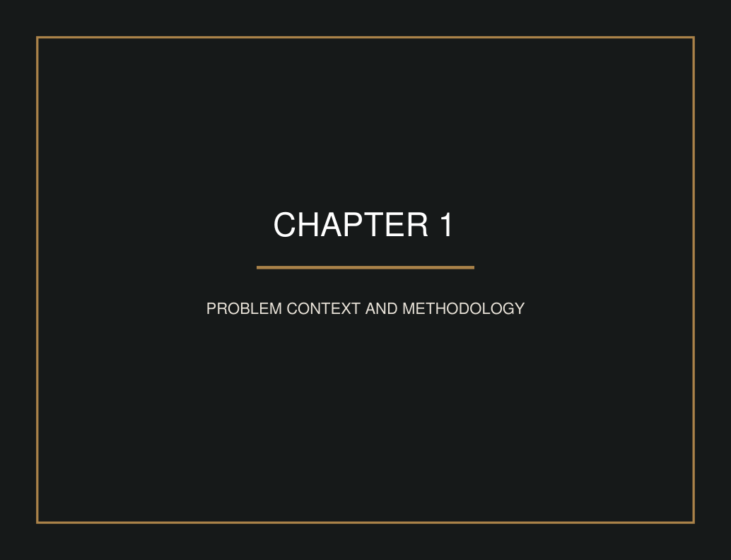

CHAPTER 1: PROBLEM CONTEXT & METHODOLOGY

1.1 Project Background
Art is no longer discovered only inside a physical gallery. Collectors now expect to search, compare and buy work through digital platforms. Artists also use online channels to reach new audiences. However, when information is spread across many social media accounts, messages and payment methods, the process becomes confusing and difficult to manage.
Snadai was created as a focused digital space for contemporary art. The name “Snadai” relates to creative work and achievement. The platform combines artwork discovery, collector tools, live bidding, purchasing and artist submission in one website. Its main users are art collectors, general visitors and artists who want a more organised experience.
The system is a React single-page application. Supabase is used as the cloud service for account login, database records, real-time bid updates and uploaded submission files. The current version is a working academic prototype. It demonstrates the complete user flow while clearly separating finished functions from functions that still need production services.

1.2 Current Problems

A. Discovery and Information Barriers
Art buyers often see only separate posts or gallery advertisements. Important details such as the artist, medium, size, year and price may not follow the same format. This makes comparison slow and may reduce trust.

B. Fragmented Collector and Artist Tools
A buyer may save pictures in one place, discuss prices in another place and pay through a different channel. Artists may send portfolios by email or direct message without knowing whether the files were received. The lack of one organised platform creates repeated work for everyone.

C. Transaction and Auction Trust
Online bidding must update quickly, reject bids that are lower than the current price, and settle payment without letting either side cheat the other. Orders, favourites and submissions also contain private user information, so a platform must control who can read or add this data. Snadai answers this with database rules for private records, a shared auction deadline stored on the server instead of in the browser, and a payment gateway that only marks an order paid after independently checking the amount with the payment provider itself.

1.3 Goal and Objectives
The main goal of Snadai is to build a clear and secure online environment where people can discover, collect and support contemporary art, while artists can present their work to a gallery team.
- Create a consistent catalogue with search, filters and clear artwork details.
- Make the platform easy to use on desktop and mobile screens.
- Support collector activities through favourites, cart, checkout and order history.
- Use authenticated accounts and database security rules to protect personal records.
- Give artists a direct submission form with secure file upload.
- Provide live auction updates so bidders can see new bids without refreshing the page.

1.4 Methodology & Project Plan
This project used a quantitative survey together with an exploratory and iterative software development method. First, the problem and target users were defined. Next, the main user journeys were planned and translated into page designs. The application was then developed feature by feature and reviewed through manual checks.
Primary data: 58 Google Forms responses collected from 20 to 22 September 2026, supported by user comments, classroom feedback and manual task testing. The survey contained 20 questions about discovery habits, buying problems, trust, payment, platform features and artist needs. Secondary data: official React, Vite and Supabase documentation, examples from gallery websites, and software security guidance.

1.4.1 Methodology Methods and Tools
Area | Choice | Reason
Front end | React 19.2 | Reusable page components and interactive state.
Build tool | Vite 8 | Fast development server and simple production build.
Routing | React Router DOM 7 | Controls navigation inside the single-page application.
Cloud services | Supabase | Combines authentication, PostgreSQL, Realtime and Storage.
Icons | lucide-react | Provides clean and consistent interface icons.
Testing | Manual browser testing and ESLint | Checks main task flows and common code issues.

1.4.2 Project Planning Timeline
Phase | Planning | Research | Design | Build | Test
Requirements | ● | ●
Personas and journeys |  | ● | ●
UI and technical prototype |  |  | ● | ●
Database and integration |  |  |  | ● | ●
Review and presentation |  |  |  |  | ●

Figure 1.1 Project planning timeline map
The plan moves from understanding the problem to designing, building and testing. Some phases overlap because feedback from one feature may require a design change in another feature. This flexible process was useful for the auction, checkout and submission flows.



CHAPTER 2: RESEARCH AND OPPORTUNITY

2.1 Primary Research
The primary research used a Google Forms questionnaire with 58 response rows. It was shared online from 20 to 22 September 2026. Most respondents were young adults: 56 people (96.6%) were aged 18–24, one was under 18 and one was aged 25–34. This means the findings mainly represent young digital users and should not be treated as a complete picture of every age group in Cambodia.
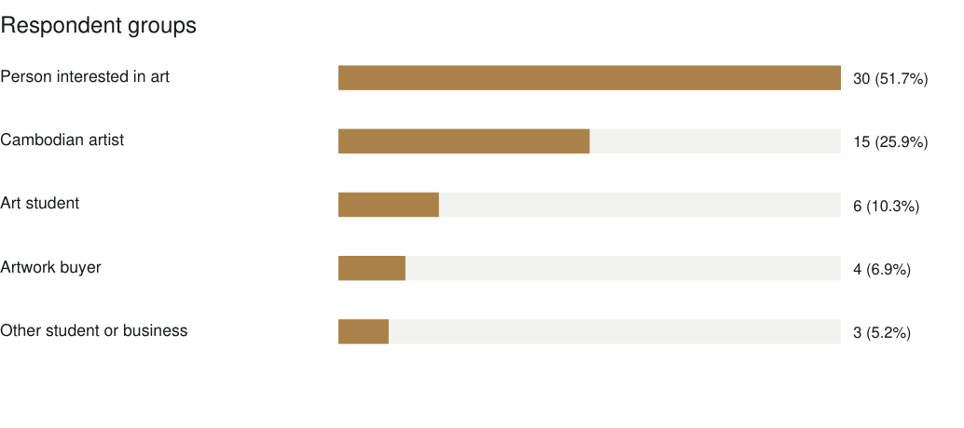
Figure 2.1 Survey respondent groups (n=58)
People interested in art formed the largest group with 30 responses (51.7%). The sample also included 15 Cambodian artists (25.9%), six art students (10.3%) and four artwork buyers (6.9%). This mix includes both people who may buy or view art and artists who need promotion and sales support.
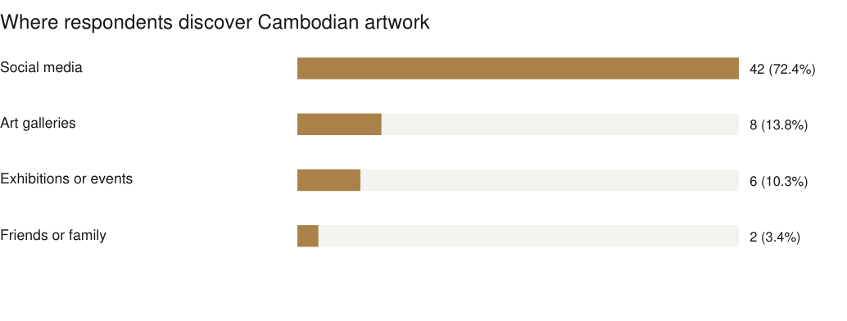
Figure 2.2 Artwork discovery channels (n=58)
Social media was the main discovery channel, selected by 42 respondents (72.4%). This supports a digital-first platform, but it also shows that Snadai should work together with social media promotion instead of trying to replace it.
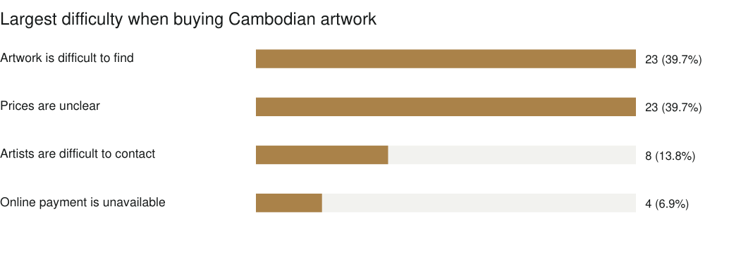
Figure 2.3 Main buying difficulties (n=58)
Difficulty finding artwork and unclear prices were tied as the largest problems, each selected by 23 respondents (39.7%). Eight people said artists are difficult to contact, while four selected the lack of online payment. For this reason, the catalogue should make artwork easy to search and should show the price, artist and important details clearly.
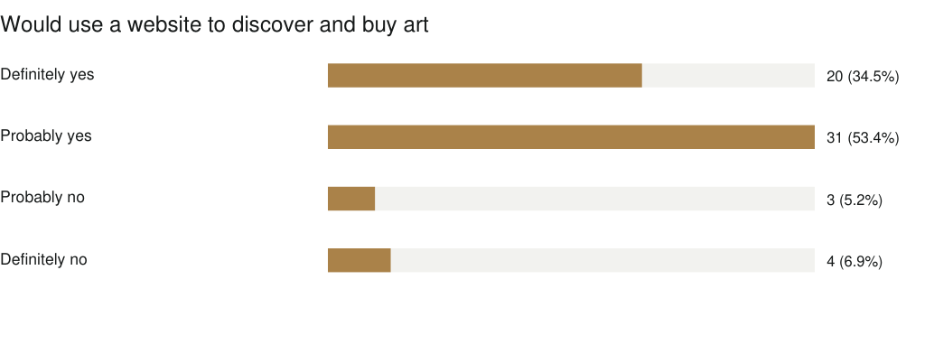
Figure 2.4 Interest in an online artwork platform (n=58)
Twenty respondents answered “Definitely yes” and 31 answered “Probably yes”. Together, 51 of 58 people (87.9%) showed positive interest in a website for discovering and buying Cambodian artwork. This gives direct support for the Snadai project idea.

Trust, payment and content preferences
Verified artist profiles were the strongest trust factor, selected by 27 respondents (46.6%). Customer reviews received 13 responses, secure payment received 11, and a clear return policy received seven. For payment, ABA Pay was strongly preferred by 47 respondents (81.0%), followed by cash on delivery with seven, credit or debit card with three, and bank transfer with one.
For artwork information, meaning or story was selected by 21 people, price by 19, size and materials by 11, artist biography by six, and one person wanted all information. In addition, 45 respondents (77.6%) said Khmer and English language support was very important. These results support complete artwork pages, verified artist information, bilingual content and local payment options.

Feature, spending and charity auction findings
Artwork search and filtering was the most requested feature with 31 responses (53.4%). Artist profiles received 15 responses, secure online checkout received seven, and online charity auctions received five. The most common normal spending range was $20–$50, selected by 33 respondents (56.9%). Sixteen selected less than $20, seven selected $51–$100 and two selected more than $100.
Interest in online charity auctions was positive: 19 respondents answered “Definitely yes” and 34 answered “Probably yes”. A total of 55 respondents (94.8%) considered it very important or important to know that part of auction income is donated to charity. This supports Snadai’s auction feature and shows that the platform should clearly explain how donated money is calculated and delivered.

Artist-focused findings
The largest artist difficulties were finding customers, selected by 27 respondents, and promoting artwork, selected by 24. Thirty-two respondents said they would probably submit artwork to the Snadai team and 23 said definitely yes, giving 55 positive responses (94.8%). For a service fee after a sale, less than 5% and 5%–10% were tied with 22 responses each. Finally, 26 respondents strongly agreed and 30 agreed that Snadai could help Cambodian artists reach more customers. This is 56 of 58 respondents, or 96.6%.

2.2 User Typology
User Group | Main Challenge | System Requirement
Art-interested visitor (30 surveyed) | Needs an easy way to discover and understand artwork. | Search, filters, story, price and clear details.
Cambodian artist (15 surveyed) | Needs promotion and access to customers. | Verified profile, submission form and fair service fee.
Art student (6 surveyed) | Needs learning, inspiration and affordable art access. | Bilingual content, artist background and low-cost options.
Artwork buyer (4 surveyed) | Needs trust, payment choice and purchase records. | Verified artists, ABA Pay, checkout and order history.
Gallery staff (future) | Needs to review content and manage sales. | Admin dashboard, moderation and reporting tools.

2.3 User Persona & Journey Map
Persona | Background | Challenge | Goal
Dara - art-interested user | Age 22; discovers art on social media. | Artwork is difficult to find and prices are unclear. | Search, compare and view complete information.
Sophea - Cambodian artist | Age 23; promotes work online. | Finding customers and promotion take time. | Create a verified profile and submit work online.
Vannak - artwork buyer | Age 24; prefers ABA Pay. | Needs trust before paying online. | See verified artists, clear prices and secure checkout.

Figure 2.5 Survey-based user persona profiles
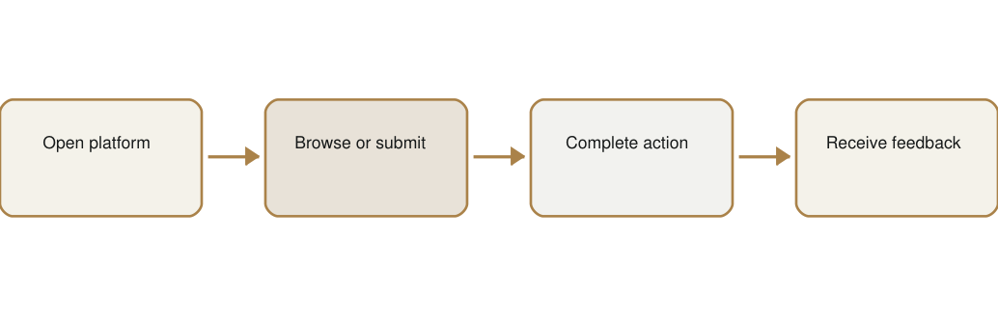
Figure 2.6 Simplified Snadai user journey

2.4 Design Criteria

Personal Guidance
Buttons and page titles use direct words such as “Add to Cart”, “Place Bid” and “Submit Artwork”. The login prompt appears only when a protected action is selected.

Art and Gallery Focus
Large artwork images, serif headings and open spacing keep attention on the work. Product information follows the same order on each detail page.

Information Sensitivity
Personal orders, favourites and submissions are connected to the logged-in user. Database policies use the user identity to limit access.

Modern Web Experience
The layout adapts at common screen widths, navigation is handled without full page reloads, and Realtime is used for new auction bids.



CHAPTER 3: DESIGN PROPOSAL

3.1 Design Statement
Snadai uses a quiet gallery design so that artwork remains the main focus. The system combines catalogue browsing, account services, live auction, artist submission and a purchase flow. Each function is placed in a clear page, while the visual style stays consistent through dark text, warm gold highlights and light backgrounds.

3.2 Mood Board
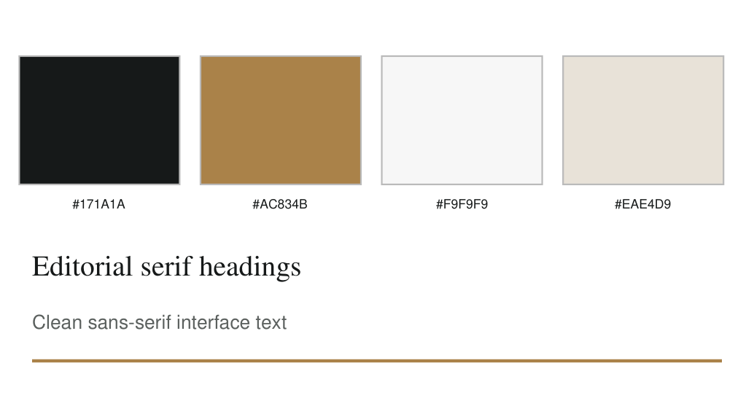
Figure 3.1 Snadai visual branding mood board

3.3 Design Direction & Core Features
- Artwork catalogue with text search and medium filter.
- Detailed artwork page with related works.
- Email and password account registration and login, plus Google sign-in, and password reset.
- Favourites stored for each authenticated user.
- Local cart with checkout and real ABA PayWay payment by card or KHQR, currently pointed at PayWay’s sandbox.
- Live auction with a shared server-side deadline, automatic round restarts and Realtime bid updates.
- Artist submission form with multi-image upload and preview.
- Profile page with account data, and an order tracker with delivery status.
- Email notifications for outbid alerts and auction wins.
- Responsive layouts for desktop and smaller screens.

3.4 Business Model Canvas
Partner / Area | Snadai Plan
Key partners | Artists, galleries, delivery services and a future payment provider.
Key activities | Artwork curation, catalogue management, auctions, sales and artist review.
Value offered | One organised platform for art discovery, collecting and artist submission.
Customer groups | New collectors, experienced buyers, auction users and artists.
Channels | Website, social media, exhibitions and partner galleries.
Possible revenue | Sales commission, auction commission, featured listings and delivery service fees.
Main costs | Hosting, database and storage, payment fees, content work, marketing and support.

The payment integration is real, but this build points at ABA PayWay’s sandbox rather than a live merchant account, so the figures below are planning examples rather than current income. The survey gives useful guidance for a future sales commission: 22 respondents preferred a fee below 5% and another 22 preferred 5%–10%. Together, 44 respondents (75.9%) selected a fee of 10% or less. A future version could charge this commission automatically once a live merchant account is connected. Costs would grow with image storage, traffic, email volume and transaction fees.
Period | User Goal | Activity Goal | Revenue Status
Year 1 | 500 registered users | Build artist and artwork catalogue | Pilot; test commission model
Year 2 | 2,000 registered users | Regular sales and scheduled auctions | Target sustainable service income

3.5 Design Development & Interface Evolution
The first layout focused on placing every function on the screen. During refinement, the design added more spacing, stronger image hierarchy and clearer calls to action. The purchase process was divided into cart, checkout and payment pages so users could understand each step.

Figure 3.2 Home page interface evolution
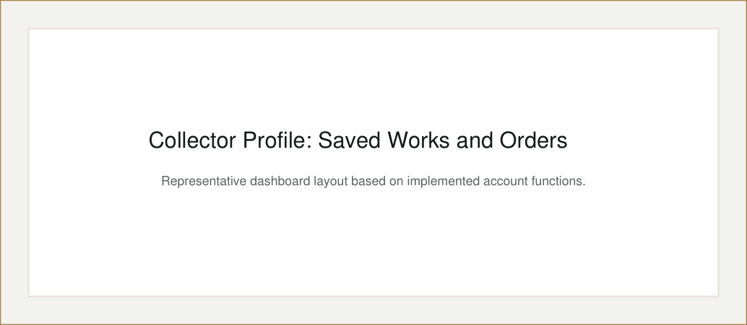
Figure 3.3 Collector dashboard evolution
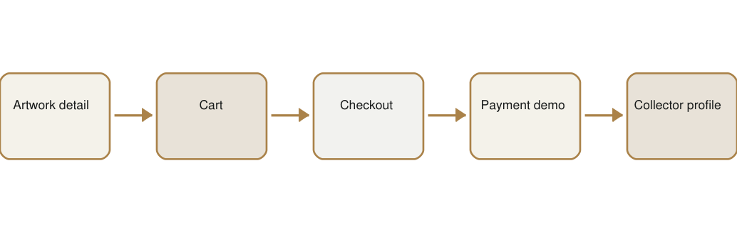
Figure 3.4 Transaction flow evolution



CHAPTER 4: FINAL DESIGN

4.1 Concept Posters
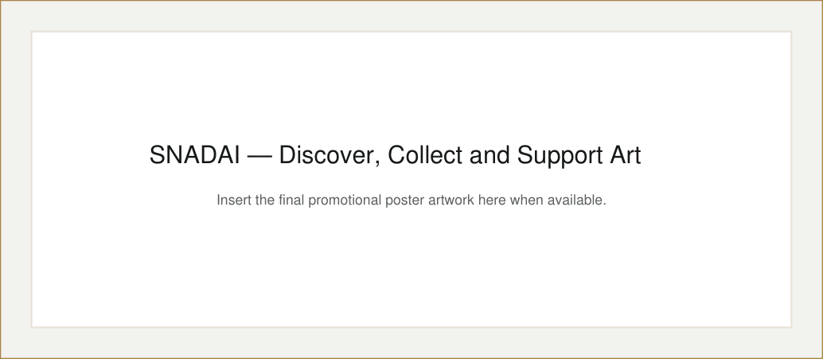
Figure 4.1 Snadai promotional poster position
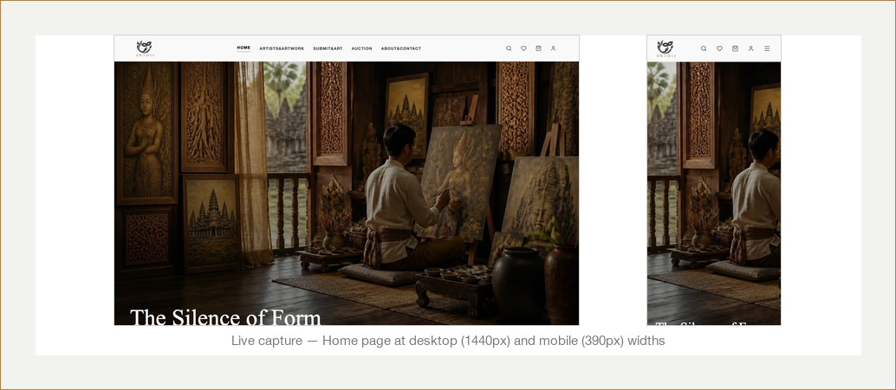
Figure 4.2 Responsive platform mock-up position
The promotional message focuses on three actions: discovering art, collecting work and supporting artists. The responsive presentation should show the same artwork and navigation adapting to both desktop and mobile width.

4.2 Brand Identity Guide
Element | Rule
Primary colour | Near black #1A1C1C for text, navigation and formal sections.
Accent colour | Warm gold #AC834B for important buttons, lines and highlights.
Background | Off-white #F9F9F9 to create a calm gallery environment.
Heading type | Times New Roman or Georgia for an editorial art-gallery style.
Interface type | Helvetica Neue or Arial for buttons, forms and readable body text.
Icons | lucide-react outline icons used consistently for common actions.
Images | Large, clean artwork images with limited decoration.

4.3 Functional Platform Demonstration
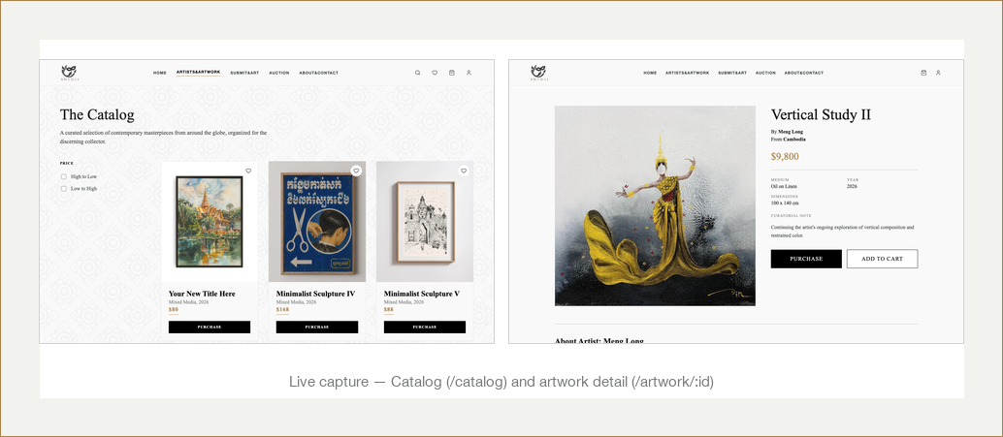
Figure 4.3 Catalogue and artwork detail demonstration
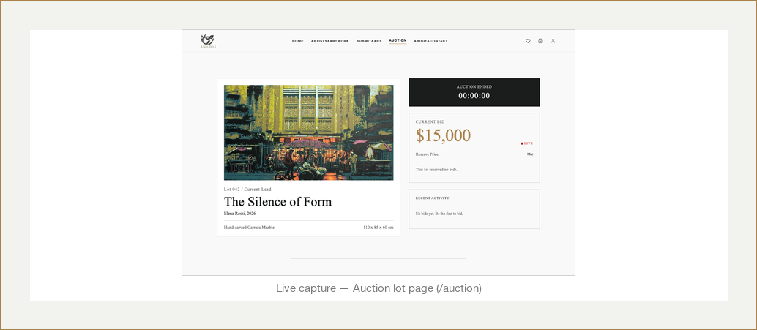
Figure 4.4 Live auction demonstration
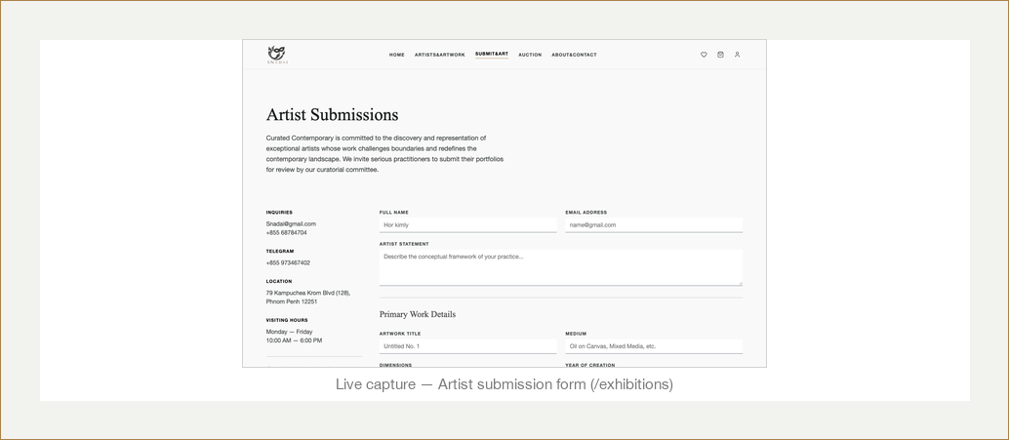
Figure 4.5 Artist submission demonstration
The current build includes working routes for login, sign-up, password reset, catalogue, artwork details, home, auction, about, artist submission, collector profile, cart, checkout, payment and account profile. Protected actions open an authentication prompt when the visitor is not logged in.



CHAPTER 5: PRODUCTION TECHNOLOGY STACK SPECIFICATIONS

5.1 Technology Stack Layer Summary
Layer | Technology | Use in Snadai
Client interface | React 19.2 | Builds pages with function components and Hooks.
Build and development | Vite 8 | Runs the development server and creates the production build.
Navigation | React Router DOM 7 | Maps web addresses to page components.
Authentication | Supabase Auth | Manages email login, sessions and password recovery.
Database | Supabase PostgreSQL | Stores bids, orders, favourites and submissions.
Live updates | Supabase Realtime | Sends new auction bids to connected users.
File storage | Supabase Storage | Stores artwork files sent through artist submissions.
Browser storage | localStorage | Keeps the cart on the current browser.
Icons | lucide-react | Provides interface icons.

These choices reduce the number of separate services required for an academic prototype. React supports reusable interactive pages, and Vite keeps the development setup simple. Supabase provides several backend services in one project. However, the system still needs careful database policies because the client connects directly to the Data API.

5.2 Technology Interaction Overview
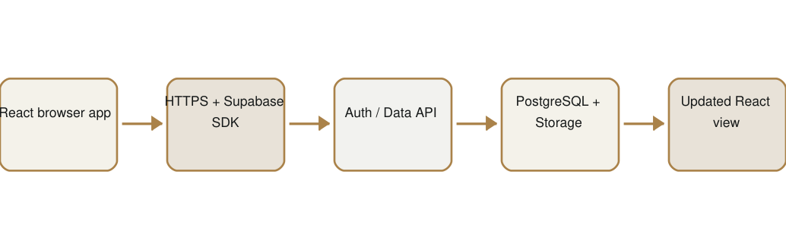
Figure 5.1 Technology interaction overview
When a user signs in, Supabase Auth creates a session and the client library sends the user token with later requests. Database rules check the user identity before allowing private operations. Catalogue data is currently imported from a static JavaScript file, while bids, orders, favourites and submissions use Supabase. Realtime listens for new bid records and updates the auction screen.
The public Supabase project URL and anonymous key are stored in Vite environment variables. These values identify the project, but security depends on Row Level Security policies. Sensitive service-role credentials must never be placed in the browser. A future real payment flow must use a trusted server or serverless function so private payment secrets and amount validation remain outside the client.



CHAPTER 6: FUNCTIONAL & NON-FUNCTIONAL REQUIREMENTS

6.1 Functional Requirements (FR) Matrix
ID | Module | System Requirement
FR-1.1 | Registration | The system shall allow a visitor to create an account with email and password.
FR-1.2 | Login | The system shall allow a registered user to sign in and sign out.
FR-1.3 | Password recovery | The system shall send a password reset link and allow a new password.
FR-2.1 | Catalogue | The system shall display the artwork catalogue and complete artwork details.
FR-2.2 | Search and filter | The system shall filter artwork by text and medium.
FR-2.3 | Favourites | The system shall allow an authenticated user to save and remove favourites.
FR-3.1 | Cart | The system shall add, list and remove artwork in the browser cart.
FR-3.2 | Checkout | The system shall collect shipping information and calculate totals.
FR-3.3 | Orders | The system shall create a pending order for the signed-in user at checkout and update it to paid once payment settles.
FR-4.1 | Auction | The system shall display recent bids and the current highest amount.
FR-4.2 | Bid validation | The database shall reject a bid that does not exceed the current maximum.
FR-4.3 | Realtime | The auction page shall receive newly inserted bids without manual refresh.
FR-5.1 | Submission | The system shall allow an artist to enter work information and upload images.
FR-5.2 | Profile | The system shall show account information and order history.
FR-5.3 | Access gate | The system shall request login before a protected action is completed.
FR-1.4 | OAuth login | The system shall let a user sign in with a Google account instead of email and password.
FR-3.4 | Payment creation | The system shall create an ABA PayWay transaction (card or KHQR) from the order’s own stored total, never from a client-supplied amount.
FR-3.5 | Payment settlement | The system shall mark an order paid only after independently confirming the amount with ABA PayWay, never from the client or an unsigned callback alone.
FR-3.6 | Order tracking | The system shall show a five-stage delivery tracker (confirmed, processing, shipping, out for delivery, delivered) for each order.
FR-4.4 | Auction deadline | The system shall store one shared closing time per lot so every visitor sees the same countdown.
FR-4.5 | Winner resolution | The system shall offer the lot to the highest bidder first, then the next-highest, if an earlier bidder does not pay within their window, and automatically reopen the lot for a new round if all miss their window.
FR-4.6 | Bid notifications | The system shall email a bidder when someone places a higher bid, and email the winner when the lot closes in their favour.

6.2 Non-Functional Requirements (NFR) Constraints
ID | Quality Area | Constraint / Target
NFR-1 | Performance | Normal catalogue interactions should respond immediately; cloud requests should normally return within 2-3 seconds on a stable connection.
NFR-2 | Usability | Main actions must use clear labels and work at desktop and mobile breakpoints.
NFR-3 | Security | All production traffic must use HTTPS. Private tables and storage paths must use Row Level Security.
NFR-4 | Reliability | Failed uploads, bids and orders must show a useful error instead of silent failure.
NFR-5 | Scalability | Frequently queried database fields should use suitable indexes, and media should be stored outside database rows.
NFR-6 | Maintainability | Common navigation and repeated layout code should be moved into shared components in a future refactor.
NFR-7 | Compatibility | The production build should run in current versions of major desktop and mobile browsers.



CHAPTER 7: SYSTEM ARCHITECTURE & DATABASE DESIGN

7.1 Hardware and Infrastructure Map
Infrastructure Node | Type | Responsibility
Desktop / mobile browser | User device | Renders the React interface and manages local view state.
Static web host | Cloud hosting | Delivers the Vite production files.
Supabase Auth | Managed service | Creates sessions, issues tokens and handles password recovery.
PostgreSQL database | Managed relational database | Stores bids, orders, favourites and submission records.
Supabase Realtime | WebSocket service | Sends new bid events to auction clients.
Supabase Storage | Cloud object storage | Stores artist submission image files.
Supabase Edge Functions | Serverless (Deno) | Runs payment creation and settlement and win/outbid email, and holds every third-party secret server-side.
pg_cron scheduler | Managed Postgres extension | Checks every minute whether a closed lot’s restart gap has passed and reopens it for a new round.
ABA PayWay | External payment gateway | Hosts the card checkout page and KHQR generation; Snadai never touches card numbers directly.
Mailgun | External email service | Delivers outbid and auction-win notification emails.

Figure 7.1 Snadai infrastructure map

7.2 Database Table Design & Schema Definitions
Table / Store | Important Fields | Purpose
auth.users | id, email, metadata | Managed account identity and profile metadata.
bids | id, lot_id, user_id, bidder_name, amount, created_at | Live auction bid records.
orders | user_id, items, totals, shipping, status, payway_tran_id, delivery_status, carrier, tracking_number | Purchase record, ABA PayWay transaction link and delivery tracker fields.
favorites | user_id, artwork_id | Saved artwork links for each collector.
submissions | user_id, artist data, artwork data, file_path | Artist application information and uploaded file locations.
storage.objects | bucket_id, name, owner data | File metadata for submission images.
localStorage: snadai_cart | Artwork item array | Browser-only cart; not part of PostgreSQL.
lots | id, closes_at, round, round_duration, restart_gap | Shared auction deadline and round state for the lot.

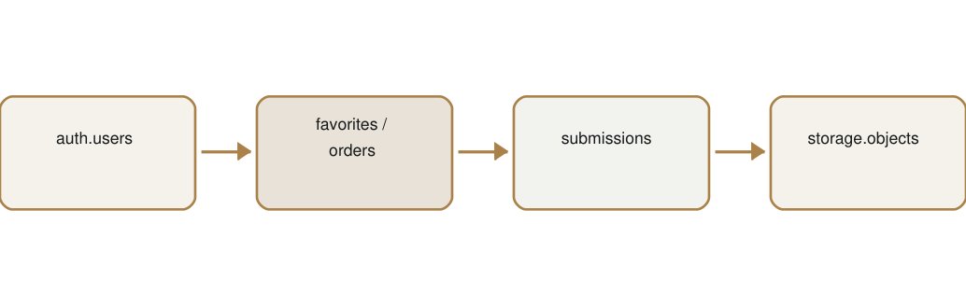
Figure 7.2 Simplified entity relationship diagram
The bids table links each record to an authenticated user and an auction lot. A database trigger checks that a new amount is greater than the current highest bid. Orders, favourites and submissions are protected by policies that compare the row user_id with the signed-in user. Submission files are stored under a folder beginning with the user ID.

7.3 System Security and Data Integrity Controls
- Supabase Auth manages email, password and Google sign-in sessions and supplies JSON Web Tokens.
- Row Level Security limits orders, favourites and submissions to their owners.
- A database trigger and a security-definer SQL function provide server-side bid and round checking and reduce race-condition risk.
- Submission files use user-specific storage paths and access policies.
- The anonymous client key may be used in the browser, but service-role keys, the PayWay API key and the Mailgun key stay inside Supabase Edge Functions and are never sent to the client.
- An order is only marked paid after an Edge Function re-checks both the transaction status and the exact amount with ABA PayWay directly; the unsigned callback PayWay posts back is treated only as a hint to go verify, never as proof.
- Input validation should be applied in both the interface and database whenever possible.

7.4 End-to-End Technical Flow Walkthrough
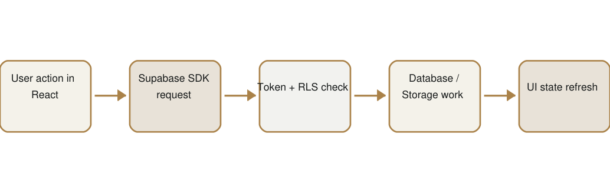
Figure 7.3 End-to-end technical flow
Example: when a user places a bid, the auction form first checks that the value is a valid positive number. The Supabase client sends an insert request with the active user session. PostgreSQL applies the insert policy and the bid-check trigger. If the amount is accepted, the row is stored. Realtime then sends the new row to connected auction screens, and React adds it to the displayed bid list.



CHAPTER 8: CONCLUSION & FUTURE WORK

8.1 Summary
Snadai began with the idea of bringing artwork discovery, collector activities, live bidding and artist submission into one organised website. The work moved from problem research and user journeys to visual design, React development and Supabase integration. The final prototype contains a connected set of pages for the main user tasks.
The survey of 58 respondents gave strong support for the project. Fifty-one people (87.9%) were positive about using a website to discover and buy Cambodian artwork, and 56 people (96.6%) agreed that Snadai could help Cambodian artists reach more customers. The results also gave clear design priorities: search and filtering, visible prices, verified artist profiles, Khmer and English content, ABA Pay and a simple artist submission process.
The project demonstrates account authentication with email or Google sign-in, protected user actions, catalogue search, favourites, a browser cart, a real ABA PayWay checkout, a database-backed live auction with automatic round restarts, email notifications and secure artist file uploads. It also documents the limits of the current version. Artwork content is still static, the payment gateway runs against a sandbox rather than a live merchant account, only one auction lot exists, and some database table creation scripts are incomplete.

8.2 Lessons Learned
The project improved my understanding of how front-end pages communicate with cloud services. I learned that a working interface is not enough; database rules are also needed to protect private data. The live auction showed the importance of server-side validation because two users may bid at nearly the same time.
The research also taught me to connect design choices to evidence. For example, the survey showed that 42 people discover art through social media, 47 prefer ABA Pay, and 45 consider Khmer and English support very important. These results are more useful than guessing what users may want.
I also learned that repeated code becomes difficult to maintain. The same header and navigation are copied into many pages, so a future refactor should create one shared layout component. The checkout flow also taught me to separate a visual prototype from a real payment system and to describe that difference clearly.

8.3 Future Development Plans
- Move the payment gateway from ABA PayWay’s sandbox to a live merchant account.
- Move artwork and artist content from the static array into database tables with an admin management page.
- Store cart items by account and clear the cart after a successful order.
- Support more than one auction lot running at the same time, instead of a single hardcoded lot.
- Connect a real carrier tracking API so delivery status updates automatically instead of by hand.
- Create a gallery review dashboard for artist submissions.
- Add Khmer language support and improve accessibility labels and keyboard navigation.
- Create automated unit, integration and end-to-end tests.
- Refactor repeated navigation and page styles into reusable components.
- Add analytics and reports for sales, submissions and user activity.
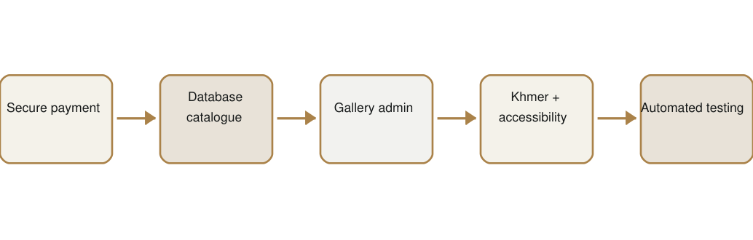
Figure 8.1 Proposed future development roadmap



CHAPTER 9: APPENDIX & REFERENCES

9.1 Initial Research Findings
Finding | Project Response
Artwork details are often inconsistent across informal channels. | Use one artwork data structure and a consistent detail page.
Collectors need time before deciding. | Provide user favourites and a persistent browser cart.
Bidding must be fair and current. | Use a server-side bid rule and Realtime subscription.
Artists need a clear submission channel. | Provide a structured form, image previews and private upload path.
Private records must not be shared between users. | Use authenticated user IDs and Row Level Security policies.
Users may enter from any page. | Use an authentication gate at protected actions.

The survey was collected through Google Forms from 20 to 22 September 2026 and contains 58 response rows. Percentages in this report were calculated from the 58 total responses unless a question contained a blank or custom answer.
Q | Strongest Survey Result | Count
1 | Age 18–24 | 56 (96.6%)
2 | Person interested in art | 30 (51.7%)
3 | Sometimes buys/views Cambodian art | 33 (56.9%)
4 | Discovers art through social media | 42 (72.4%)
5 | Hard to find / unclear prices (tie) | 23 each (39.7%)
6 | Probably use an art website | 31 (53.4%)
7 | Meaning of the artwork | 21 (36.2%)
8 | Verified artist profiles | 27 (46.6%)
9 | ABA Pay | 47 (81.0%)
10 | Bilingual support is very important | 45 (77.6%)
11 | Definitely read artwork story | 33 (56.9%)
12 | Artwork search and filtering | 31 (53.4%)
13 | Normal spend of $20–$50 | 33 (56.9%)
14 | Probably join charity auction | 34 (58.6%)
15 | Charity donation information important | 28 (48.3%)
16 | Finding customers | 27 (46.6%)
17 | Probably submit artwork online | 32 (55.2%)
18 | Submit all listed information | 20 (34.5%)
19 | Below 5% / 5%–10% fee (tie) | 22 each (37.9%)
20 | Agree Snadai can help artists | 30 (51.7%)

9.2 User Testing Feedback Matrices
Test Area | Expected Result | Current Status / Improvement
Registration and login | User can create and access an account. | Implemented; add clearer validation messages where needed.
Catalogue search | Matching artwork appears while typing. | Implemented with client-side text matching.
Favourite action | Saved item appears in collector profile. | Implemented for authenticated users.
Cart and checkout | Totals remain correct through the flow. | Implemented as a demo; cart should clear after success.
Auction bid | Low bid is rejected and accepted bid appears live. | Database trigger and Realtime are implemented.
Artist upload | Selected images show previews and upload safely. | Implemented; add file size/type limits.
Responsive navigation | Pages remain usable on small screens. | Responsive rules exist; complete device testing is required.
Payment | Real provider confirms the charge. | Implemented against ABA PayWay’s sandbox; still needs a live merchant account before launch.

Recommended testing participants should include a first-time art visitor, a regular online buyer, an artist and a technical reviewer. Each person should complete a short task list while the tester records errors, hesitation and comments. The final appendix should then include the real date, participant background, result and correction made.

9.3 Academic References
Kimly, H. (2026). SNADAI questionnaire responses [Unpublished Google Forms survey, 58 responses].
Meta Open Source. (2026). React documentation: Quick Start and React reference. https://react.dev/learn
Supabase. (2026). Authentication documentation. https://supabase.com/docs/guides/auth
Supabase. (2026). Database overview and Row Level Security. https://supabase.com/docs/guides/database/overview
Supabase. (2026). Row Level Security documentation. https://supabase.com/docs/guides/database/postgres/row-level-security
Supabase. (2026). Storage access control. https://supabase.com/docs/guides/storage/security/access-control
Supabase. (2026). Realtime documentation. https://supabase.com/docs/guides/realtime/getting_started
Vite. (2026). Vite 8 getting started guide. https://v8.vite.dev/guide/
ABA PayWay. (2026). Payment Gateway API documentation. https://www.payway.com.kh/developers
Mailgun. (2026). Sending email with the Mailgun API. https://documentation.mailgun.com/
Supabase. (2026). Edge Functions documentation. https://supabase.com/docs/guides/functions
Supabase. (2026). Database Webhooks documentation. https://supabase.com/docs/guides/database/webhooks

Appendix A: Route and Page Inventory
Route | Page / Purpose
/ | Login
/sign-up | New account
/reset-password | Password request and update
/home-page | Marketing home
/catalog | Artwork browsing and search
/artwork/:id | Artwork information
/auction | Live bidding
/exhibitions | Artist submission form
/collector-profile | Saved artworks
/cart | Cart review
/checkout | Shipping details
/payment | ABA PayWay checkout
/Profile | Account and orders
/about | Project information
/privacy-policy | Privacy information
/payment/success | ABA PayWay card return page
/orders | Order list and delivery tracker
/orders/:orderId | Single order tracker
/AuctionResults | Auction outcome and payment window

Appendix B: Known Limitations
- The payment gateway (ABA PayWay) is connected for real, but this build points at its sandbox environment, not a live merchant account.
- Only one auction lot (lot-042) exists; the schema supports more, but the interface does not yet manage multiple lots.
- Artwork data is hardcoded and includes one unfinished placeholder item.
- The cart is stored by browser, not by user account, and is not cleared automatically after a successful order.
- Some account-setting checkboxes are visual only.
- The navigation and styles are repeated across many components.
- Delivery status on an order is updated by hand rather than through a real carrier tracking API.
- No automated test framework or continuous integration workflow is configured.

Appendix C: Setup Notes
Create a local .env file with VITE_SUPABASE_URL and VITE_SUPABASE_ANON_KEY. Install dependencies with npm install, then start the development version with npm run dev. The Supabase project must contain the required tables, policies, Realtime configuration, the pg_cron extension and the submissions storage bucket. The Edge Functions (create-payway-transaction, payway-callback, payway-status, send-auction-win-email, send-bidding-notification) must be deployed separately with supabase functions deploy, each with its own secrets set through supabase secrets set: PAYWAY_MERCHANT_ID, PAYWAY_API_KEY, PAYWAY_BASE_URL and SITE_URL for payment, and MAILGUN_API_KEY and MAILGUN_DOMAIN for email. The bidding-notification function also needs a BIDS_WEBHOOK_SECRET and a Database Webhook on bids INSERT that sends it. Before production release, point PAYWAY_BASE_URL at ABA PayWay’s live endpoint, remove sample personal data and fix the remaining incomplete artwork placeholder.

